**BL 8.0.1 trXAS 2018-02**

**02/12/18**

1st MEG, 50/50 slits, 540 eV, Large PD 🡪 60 µA (undulator gap 39.04 mm)

TDC Scan 550 periodic noise incoupling, no X-rays, no laser, -4150V, Al filter

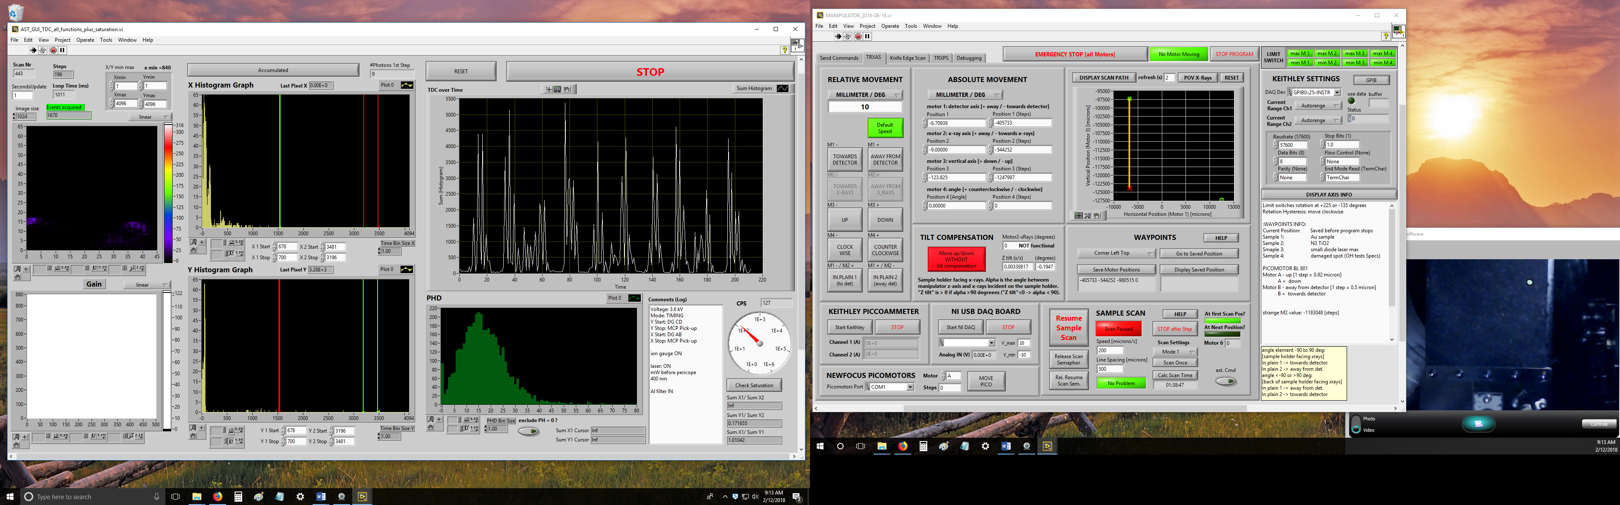

XAS O1s 120 **CuO** 40/40 slits, coarse (1eV), 200µm/s, -4150V, Izero on Keithley Ch2, Al

Izero on Keithley Ch2 (now without BL amplifier)

XAS O1s 122 **CuO** 40/40 slits, 200µm/s, -4150V, Izero on Keithley Ch2, Al filter

XAS O1s 123 **TiO2** 40/40 slits, not scanned, coarse scan, -4150V, Izero on Keithley Ch2, Al filter

XAS O1s 124 **TiO2** 40/40 slits, not scanned, -4150V, Izero on Keithley Ch2, Al filter

XAS O1s 125 **C60-TiO2 (top)** 40/40 slits, 200µm/s, -4150V, Izero on Keithley Ch2, Al filter

XAS O1s 126 **C60-TiO2 (bottom)** 40/40 slits, 200µm/s, -4150V, Izero on Keithley Ch2, Al filter

XAS Ti2p 127 **TiO2** 40/40 slits, not scanned, coarse, -4150V, Izero on Keithley Ch2, Ti filter

XAS Ti2p 128 **TiO2** 45/45 slits, not scanned, -4150V, Izero on Keithley Ch2, **Ti filter**

XAS Ti2p 129 **TiO2** 45/45 slits, not scanned, -4150V, Izero on Keithley Ch2, **Al filter**

**ratio of pre-edge peak and first actual resonance is similar for both filters, Ti has better transmission**

XAS Ti2p 131 **C60-TiO2 (top)** 45/45 slits, 200µm/s, -4150V, Izero on Keithley Ch2, Ti filter

XAS Ti2p 132 **C60-TiO2 (bottom)** 45/45 slits, 200µm/s, -4150V, Izero on Keithley Ch2, Ti filter

XAS C1s 133 **C60-TiO2 (bottom)** 60/60 slits, coarse, 200µm/s, -4150V, Izero on Keithley Ch2, Ti

XAS C1s 134 **C60-TiO2 (bottom)** 60/60 slits, 200µm/s, -4150V, Izero on Keithley Ch2, Ti

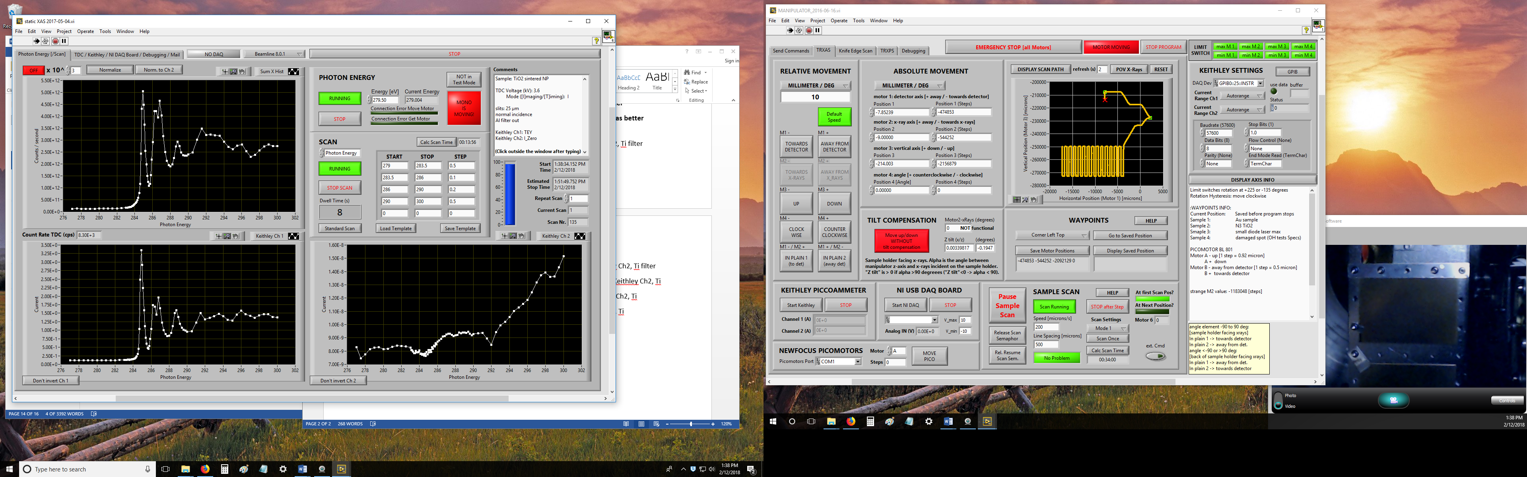

XAS C1s 136 **C60-TiO2 (top)** 60/60 slits, 200µm/s, -4150V, Izero on Keithley Ch2, Ti

X-rays large PD current: adjusted holy mirror: [540eV 1st harmonic, MEG] 50µA -> 90µA

#Scan Source Direction FWHM center

2583 X-rays horizontal 187.0 16037.3

brought X-ray beam onto bottom carbon edge on PD: fluctuations from 40 to 80 µA, very periodic, not noise as with the full beam on the diode the fluctuations are much smaller

2584 X-rays vertical 52.9 -171830.9

Laser Power at viewport behind main chamber @355 nm PoD 100%, Divider 656, 127 kHz

autoNLO Power

10% 8 mW

15% 22 mW

20% 41 mW

30% 108 mW

40% 195 mW

45% 246 mW

50% 310 mW

55% 371 mW

60% 438 mW

70% 560 mW

80% 700 mW

90% 825 mW

upstream focusing mirror: 2PA 82 & 3PA 114

downstream focusing mirror 2PA 145 & 3PA 138

check spatial overlap

#Scan Source Direction FWHM center

2585 X-rays vertical 62 -171833.1

moved pico A+150 (adjusted laser on half current on large PD)

2587 Laser vertical 174.8 -171839.5

2588 X-rays horizontal 188.4 16089.6

2589 Laser horizontal 369.2 16065.7

moved focus lens by 2mm towards the sample, changed laser power autoNLO 10%

2590 Laser horizontal 369.2 16065.7

moved focus lens by 4mm towards the laser

2591 Laser horizontal 247 16050.9

moved pico B -80

2592 Laser horizontal 246.6 16073.5

moved pico B -30, changed laser power autoNLO 12%

2593 Laser horizontal 258.6 16082.1

2594 X-rays vertical 52.8 -171846.9

2595 Laser vertical 100.6 -172005.2

moved pico A+165

2596 Laser vertical 105.6 -171850.0

2597 X-rays horizontal 187.2 16133.8

2598 Laser horizontal 200.5 16142.9

moved focus lens by 1mm towards the sample

2599 Laser horizontal 249.4 16115.1

moved pico B-35

2600 Laser horizontal 257.5 16128.5

2601 X-rays vertical 55.1 -171839.5

2602 Laser vertical 132.1 -171717.0

moved pico A -150

2603 Laser vertical 135.4 -171857.0

moved pico A 20

2604 Laser vertical 130.2 -171836.7

2605 Laser horizontal 243.4 16138.6

2606 X-rays horizontal 187.2 16127.5

moved pico B +20

2608 Laser horizontal 243.4 16138.6

**adjusting timing on small diode: 355nm 127kHz (Div=656) 0.4% autoNLO 100% PoD**

time zero with 21th bunch after camshaft gap: PS=3500ps, A=T+2210ns, B=A+30ns

phase shifter at 3350ps -> 150ps pump-probe delay

TDC delay generator: A = T+1129ns, C=T+470ns

problems with weird timing jumps. no multiple of 12ns very stable before and after, might be coming from user timing system.

using old user timing system now and monitoring mike’s box, old and new timing system with respect to PRF laser output (from pulse picker, triggering scope with PRF)

PS=2550 ps time zero on 18th bunch, DG: A=T+1766ns, B=A+30ns

DG1 (Laser pulse picker)

A=T+1766ns B=A+30ns (signal to pulse picker: AB positive TTL)

C=T+783ns D=C+50ns (signal to DG2: CD positive TTL)

DG2 (TDC trigger)

A=T+1129ns B=A+4ns (signal to Xstart: AB negative NIM)

C=T+470ns D=C+4ns (signal to Ystart: CD negative NIM)

MCP voltage 4.2kV, hv=538.25eV (max of second resonance of TiO2 O K-edge):

C60-TiO2 sample, 45/45 slits: max pulse height distribution: 15, 110kCPS

TRXAS 137 **C60-TiO2 (top) O K-edge,** 45/45 slits, 150µm/s, -4200V, Izero on Keithley Ch2, Al filter, laser 150 ps before bunch #18, PS=2400ps, 500µm spacing, 49% autoNLO, 100% PoD, fluence ca. 9.4 mJ/cm2

TRXAS 138 **C60-TiO2 (top) O K-edge** same as TRXAS 137

TRXAS 139 **C60-TiO2 (top) O K-edge** same as TRXAS 137, manipulator scan crashed around 548 eV (afterward measurement at one point). Stopped the scan around 556 eV because we lost the lock of the ALS beamline signal.

checked timing on small PD and scope. Seems to be fine. Also checked spatial overlap by individually finding the max signal on the scope changing horizontal and vertical positions of the sample holder (i.e. diode). Horizontal: ok. Vertical: 25µm off but that could be hysteresis in the vertical motor (it is less precise than the horizontal ones)

TRXAS 140 **TiO2 O K-edge,** 45/45 slits, 150µm/s, -4200V, Izero on Keithley Ch2, Al filter, laser 150 ps before bunch #18, PS=2400ps, 500µm spacing, 49% autoNLO, 100% PoD, fluence ca. 9.4 mJ/cm2

timing lost at 564eV (so the scan is good!)

overlapped laser on 21st bunch

A= T+ 1621ns, C= 638ns (-145ns to before)

PS=2350ps time zero

TRXAS 142 **TiO2 O K-edge,** 45/45 slits, 150µm/s, -4200V, Izero on Keithley Ch2, Al filter, laser 150 ps before bunch #21, PS=2200ps, 500µm spacing, 49% autoNLO, 100% PoD, fluence ca. 9.4 mJ/cm2

(timing in 2D Histogram looks weird for trXAS scan #142)

**02/14/18**

2609 X-rays vertical 63.1 -142881.2

2611 Laser vertical 134.6 -142865.8

moved pico A -15

2612 Laser vertical 133.3 -142881.4

2613 X-rays horizontal 187.9 -6111.5

2614 Laser horizontal 228 -6118.3

moved pico B -10

2615 Laser horizontal 233.0 -6111.5

2616 Laser vertical 139.8 -142886.0

2617 X-rays vertical 62.3 -142881.4

adjusting timing on small PD

PS=3500ps, DG1: A=T+1912ns is time zero for the 19th bunch

PS=3350ps -> 150ps delay

TDC Scan 551 Al filter in V_MCP = 4200V, slits 45/45 hv=540eV, TiO2 NP sample, 110kCPS, relatively broad PhD centered around 20 (was 15 yesterday with equal settings)

[started with events and stopped with DG for this scan, changing back again]

TRXAS 144 **TiO2 O K-edge,** 45/45 slits, 150µm/s, -4200V, Izero on Keithley Ch2, Al filter, laser 150 ps before bunch #19, PS=3350ps, 500µm spacing, 49% autoNLO, 100% PoD, fluence ca. 9.4 mJ/cm2

X-ray bunch pattern jumped by 120 channels in the TDC window during the scan **(MAY BE USABLE[?])**

Scope (infinite persistence) traces look still good on both our and Jonah’s scope (absolutely no change!)

[each have old and new user timing system signals and mike’s box

4th cannel: Jonah: different new timing system, we: laser PRF output]

checking timing on small PD: laser now sits on 24th bunch (pump probe delay 150ps as adjusted)

**the following time distances should never change on the scope**

**PRF signal rising edge – laser signal on small PD: 205.8ns**

**camshaft signal – ALS 2x (new timing system): 98ns**

adjusting timing on small PD

PS=3500ps, DG1: A=T+1766ns, C= T+786ns is time zero for the 21st bunch

PS=3350ps -> 150ps delay

TRXAS 145 **TiO2 O K-edge,** 45/45 slits, 150µm/s, -4200V, Izero on Keithley Ch2, Al filter, laser 150 ps before bunch #21, PS=3350ps, 500µm spacing, 49% autoNLO, 100% PoD, fluence ca. 9.4 mJ/cm2

ALS lost beam

TRXAS 147 **TiO2 O K-edge** rest of 145

timing jump during 147

unplugged and plugged back in a lot of SMA cables in electronics box (1/6 divider, splitter, phase shifter, programmable frequency divider)

changed cable from input to first amp and from first amp to 1/6 divider

power supply for 1/6 div was hotter than the other two, installed fan on top of box

first four bunches barely filled at all: pay attention analyzing the data ##

bunch filling pattern in general looks shit

adjusting timing on small PD

PS=2400ps, DG1: A=T+1766ns, C= T+786ns is time zero for the 22st bunch

PS=2250ps -> 150ps delay

TRXAS 148 **TiO2 O K-edge,** 45/45 slits, 150µm/s, -4200V, Izero on Keithley Ch2, Al filter, laser 150 ps before bunch #22, PS=2250ps, 500µm spacing, 49% autoNLO, 100% PoD, fluence ca. 9.4 mJ/cm2

TRXAS 149 **TiO2 O K-edge** same as #148

TRXAS 150 **TiO2 O K-edge** same as #148 line shifted by 250 µm away from detector

(finished first scan pattern at 548eV)

TRXAS 151 **TiO2 O K-edge** same as #150

TRXAS 152 **TiO2 O K-edge** same as #150 (It looks like that the spatial overlap was off during that measurement)

check spatial overlap

2618 X-rays vertical 61.6 -142913.7

2619 Laser vertical 126.4 -142885.9

moved pico A -33

2620 Laser vertical 137.3 -142918.8

moved pico A +5

2621 Laser vertical 133.0 -142915.1

2622 X-rays horizontal 186.0 -6041.1

2623 Laser horizontal 233.1 -6132.1

moved pico B -180

2624 Laser horizontal 250.0 -6069.6

moved pico B -60

2625 Laser horizontal 245.4 -6050.7

2626 Laser vertical 143.3 -142948.4

2627 X-rays vertical 64.5 -142918.6

moved pico A +30

2628 Laser vertical 142.0 -142921.0

2629 Laser horizontal 248.7 -6041.2

2630 X-rays horizontal 190.6 -6034.6

Phase Shifter Scan 154-157 **TiO2** hv=535.6eV, 45/45 slits, 150µm/s, -4200V, Izero on Keithley Ch2, Al filter, 500µm spacing, 49% autoNLO, 100% PoD, fluence ca. 9.4 mJ/cm2

TDC Scan 555 hv=285eV, 4200V, C60-TiO2

TRXAS 159 **C60-TiO2 C K-edge** 70/70 slits, 150µm/s, -4200V, Izero on Keithley Ch2, Ti filter, laser 150 ps before bunch #22, PS=2250ps, 500µm spacing, 49% autoNLO, 100% PoD, ca. 9.4 mJ/cm2

TRXAS 160 **C60-TiO2 C K-edge** same as #159

TRXAS 161 **C60-TiO2 C K-edge** same as #159

Phase Shifter Scan 163 **C60-TiO2** hv=284.7eV, 70/70 slits, 150µm/s, -4200V, Izero on Keithley Ch2, Ti filter, 500µm spacing, 49% autoNLO, 100% PoD, ca. 9.4 mJ/cm2

Phase Shifter Scan 164-166 **C60-TiO2** same as #163

current position 15mm above small PD (waypoint saved)

**02/16/18**

2631 X-rays vertical 70.1 -142942.5

2632 Laser vertical 138.6 -142990.5

moved A+52

2633 Laser vertical 143.0 -142937.5

A-5

2634 X-rays horizontal 183.9 -6139.2

2635 Laser horizontal 250.0 -6018.0

B+230

2636 Laser horizontal 225.5 -6104.2

B+50

2637 Laser horizontal 217.5 -6124.1

B+30

2639 Laser horizontal 216.4 -6137.8

2640 X-rays vertical 78.4 -142916.9

adjusted laser to half power on X-ray half current position

2641 Laser vertical 131.3 -142913.7

2643 Laser horizontal 259.4 -6169.2

2644 X-rays horizontal 173.8 -6158.2

B -20

2645 Laser horizontal 241.2 -6160.9

adjusting timing on small PD

PS=2500ps, DG1: A=T+1850ns, C= T+870ns is time zero for the 22st bunch

PS=2350ps -> 150ps delay

Laser Power at viewport behind main chamber @355 nm PoD 100%, Divider 656, 127 kHz

autoNLO Power

10% 9 mW

15% 22 mW

20% 42 mW

30% 110 mW

40% 197 mW

45% 247 mW

49% 297 mW

50% 307 mW

55% 370 mW

60% 440 mW

70% 560 mW

80% 682 mW

90% 805 mW

TRXAS 168 **C60-TiO2 C K-edge** 70/70 slits, 150µm/s, -4200V, Izero on Keithley Ch2, Ti filter, laser 150 ps before bunch #22, PS=2250ps, 500µm spacing, 49% autoNLO, 100% PoD, ca. 9.4 mJ/cm2

TRXAS 169 **C60-TiO2 C K-edge** see #168

M2 shows 0 but is -9mm actually

TRXAS 170 **C60-TiO2 C K-edge** see #168

timing jump by about 2 ns

adjusting timing on small PD

PS=2450ps, DG1: A=T+1850ns, C= T+870ns is time zero for the 23st bunch

PS=2300ps -> 150ps delay

TRXAS 172 **C60-TiO2 C K-edge** 70/70 slits, 150µm/s, -4200V, Izero on Keithley Ch2, Ti filter, laser 150 ps before bunch #23, PS=2300ps, 500µm spacing, 49% autoNLO, 100% PoD, ca. 9.4 mJ/cm2

TRXAS 173 **C60-TiO2 C K-edge** see 172, keithley overflow, BC DAQ problem at 293.5 to 294 eV had to manually taskkill the camonitor in command window

TRXAS 176 **C60-TiO2 C K-edge** see #172

Phase Shifter Scan 177 **C60-TiO2** hv=284.8eV, 70/70 slits, 150µm/s, -4200V, Izero on Keithley Ch2, Ti filter, 500µm spacing, 49% autoNLO, 100% PoD, ca. 9.4 mJ/cm2

Phase Shifter Scan 178-187 **C60-TiO2** same as #177

TRXAS 190 **C60-Cu C K-edge** 70/70 slits, 150µm/s, -4200V, Izero on Keithley Ch2, Ti filter, laser 150 ps before bunch #23, PS=2300ps, 500µm spacing, 49% autoNLO, 100% PoD, ca. 9.4 mJ/cm2

TRXAS 191 **C60-Cu C K-edge** see #190

TRXAS 192 **C60-Cu C K-edge** see #190

TRXAS 193 **C60-Cu C K-edge** see #190

Switching to O1s

2646 X-rays vertical 66.4 -78856.4

2647 Laser vertical 128.8 -78880.6

A+25

2648 Laser vertical 130.5 -78858.8

2649 X-rays horizontal 177.0 -29677.7

2650 Laser horizontal 224.6 -29755.2

B -160

2651 Laser horizontal 237.7 -29694.0

B -30

2652 Laser horizontal 238.5 -29683.8

2653 Laser vertical 150.6 -78885.9

2654 X-rays vertical 66.3 -78861.6

A+25

2655 Laser vertical 146.8 -78856.5

checked timing on scope: ok

old fluence (2017-05): 892 mW outside chamber, 310x254 µm

now: 400mW outside chamber, 239x147µm should be same fluence 11.36mJ/cm2

* 58% autoNLO 100% PoD

XAS Scan 194 **CuO O1s** 45/45 slits, 4200V, 8s int time, not scanned

TRXAS 195 **CuO O1s** 45/45 slits 4200V, Al filter, 250µm/s scanned, 500µm spacing, PS=2300ps (150ps before bunch #23), 58%autoNLO, 355nm, 100% PoD, Divider 656

TRXAS 196 **CuO O1s** see #195

TRXAS 197 **CuO O1s** see #195

used part of the sample:

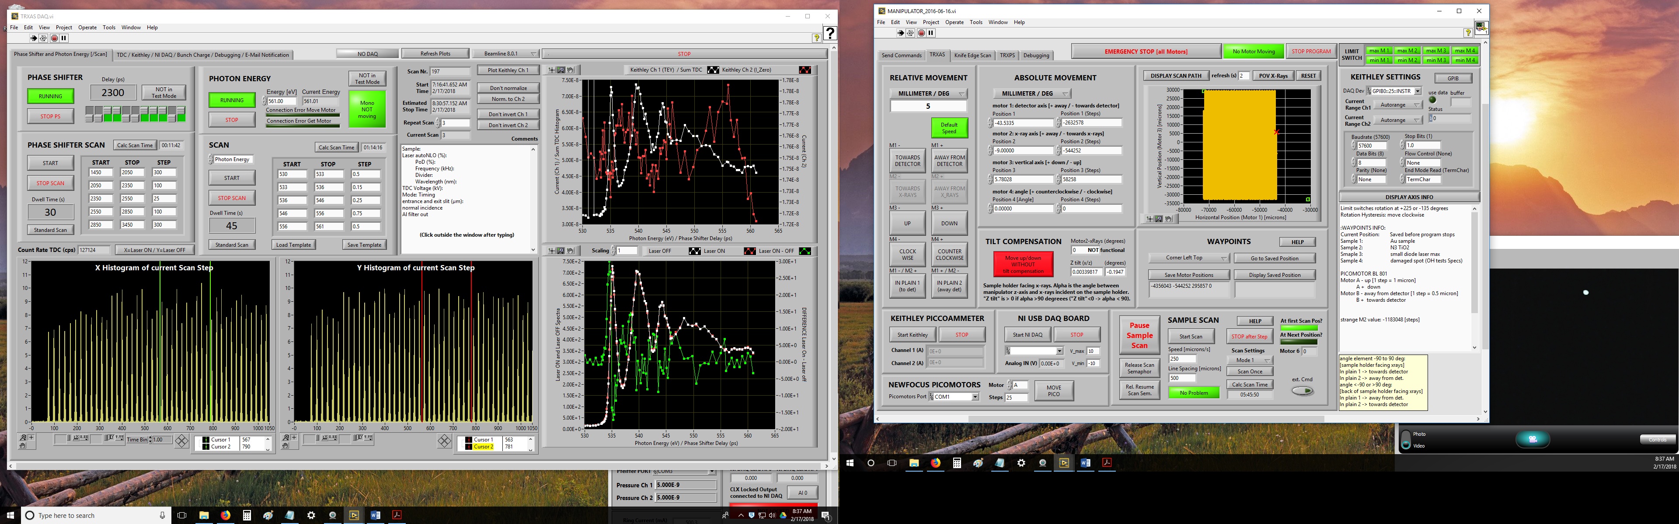

**02/18/18**

2656 X-rays vertical 66.2 -78814.1

2657 Laser vertical 138.3 -78815.0

2658 X-rays horizontal 205.4 -29573.5

2659 Laser horizontal 302.6 -29587.3

knife edge scan 400 microns lower on large PD, looks like we hit the pin of the large PD

2660 Laser horizontal 250.0 -29596.4

2661 X-rays horizontal 197.3 -29593.5

adjusting timing on small PD

PS=2500ps, DG1: A=T+1370ns, C= T+390ns is time zero for the 17st bunch

PS=2350ps -> 150ps delay2

TRXAS 198 **CuO O1s** 45/45 slits 4200V, Al filter, 250µm/s scanned, 500µm spacing, PS=2350ps (150ps before bunch #17), 58%autoNLO, 355nm, 100% PoD, Divider 656

TRXAS 199 **CuO O1s** see #198

moved on to the next sample CuO (old sample – prepared during one of the last beamtimes)

XAS Scan 200 **CuO O1s** 45/45 slits, 4200V, 8s int time, not scanned

TRXAS 201 **CuO O1s** 45/45 slits 4200V, Al filter, 250µm/s scanned, 500µm spacing, PS=2350ps (150ps before bunch #17), 58%autoNLO, 355nm, 100% PoD, Divider 656

shifted scan pattern by 250 µm away from detector

TRXAS 202 **CuO O1s** 45/45 slits 4200V, Al filter, 250µm/s scanned, 500µm spacing, PS=2350ps (150ps before bunch #17), 58%autoNLO, 355nm, 100% PoD, Divider 656

Phase Shifter Scan 204 **CuO** hv=534.8eV, 45/45 slits 4200V, Al filter, 250µm/s scanned, 500µm spacing, bunch #17, 58%autoNLO, 355nm, 100% PoD, Divider 656

Phase Shifter Scan 205-211 **CuO** same as #204

**changed to C K-edge**

XAS Scan 212 **C60-Cu C K-edge** 70/70 slits, 4200V, 8s int time, scanned 175µm/s scanned, 500µm spacing

TRXAS 214 **C60-Cu C K-edge** 70/70 slits, 160µm/s, -4200V, Izero on Keithley Ch2, Ti filter, laser 150 ps before bunch #17, PS=2350ps, 500µm spacing, 49% autoNLO, 100% PoD, ca. 9.4 mJ/cm2

TRXAS 215 **C60-Cu C K-edge** see #214

**changed back to O K-edge**

TRXAS 216 **TiO2 O K-edge,** 45/45 slits, 150µm/s, -4200V, Izero on Keithley Ch2, Al filter, laser 150 ps before bunch #17, PS=2350ps, 500µm spacing, 49% autoNLO, 100% PoD, fluence ca. 9.4 mJ/cm2

TRXAS 217 **TiO2 O K-edge** see #216

TRXAS 218 **TiO2 O K-edge** see #216